**Background:**

* 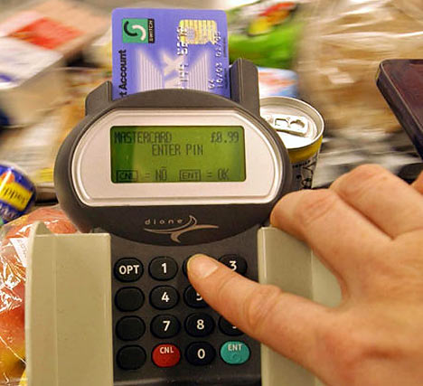PINs (Personal Identification Numbers) are used in a wide   
  range of security applications.
* Four digit PINs (e.g. 1234) are the most common as they are   
  convenient and provide some security. However, six digit PINs   
  (e.g. 123456) should be used whenever possible for improved   
  security.

**Assignment:**

1. Write a simple program that does the following:
   1. Asks the user to enter a 4 digit PIN. This will be the target PIN that the program   
      will try to “crack”.

int(input("Enter a 4 digit PIN: "))

* 1. Runs a loop that starts at 1 and stops when the target PIN is found.

startCount = int(input("Enter your 4 digit pin: "))

pin = 1

while pin <= startCount:

print("Your Pin is",pin)

pin = pin + 1

1. Enhance your basic program to include the following code:
   1. The purpose of this code is to measure how long it takes to “crack” the pin.
   2. On average, how long does it take to “crack” a PIN? Try several combinations.

startCount = int(input("Enter your 4 digit pin: "))

import time

startTime = time.time()

loopCount = 1

while (loopCount <= 1000) :

loopCount = loopCount + 1

pin = 1

while pin <= startCount:

print("Your Pin is",pin)

pin = pin + 1

endTime = time.time()

print("Elapsed time is:", (endTime - startTime) )

on average it takes about 1 second to get to the PIN number 6000

1. Many people use insecure PINs that contain repeated digits such as “1111” or simple sequences such as “1234”.
   1. Enhance your program to try some different digit repeats or digit sequences in order to crack the PIN faster.
   2. Include your enhancements before the main loop.

import time

startCount = int(input("Enter your 4 digit pin: "))

startTime = time.time()

pin = 1

my_list = (1111,1234,0000,4321)

if (startCount in my_list):

print("your pin is: ", startCount)

else:

while pin <= startCount:

print("Your Pin is",pin)

pin = pin + 1

endTime = time.time()

print("Elapsed time is:", (endTime - startTime) )

* 1. How does this affect the time needed to “crack” a PIN?

It doesn’t affect the time at all because its instant

1. Research some other ways that people choose insecure PINs. (e.g. birthday dates)
   1. Enhance your program to check for some of these insecure patterns.

1. Explain how the use of a six digit pin would increase security. Refer to some of the things you discovered while writing the programs for this assignment.

The 4 digit is combination is always 0-9 that’s 10 digits, that’s 10*10*10*10= 10,000 combinations. If you get 6 digits its 10*10*10*10*10*10 which equals 1,000,000 possibilities of combinations to crack the pin that’s why a 6 digit pin would increase security.